Unit 15: Light, Colours and Beyond
Topic: The disappearing coin
Worksheet 1
Name: _________________
Class: ______________( )
Date: __________________

Watch video clips of mirage in Death Valley.
http://www.youtube.com/watch?v=S9CztTYuGqg
http://www.youtube.com/watch?v=HzIBmuLHMSE

Try to use ray diagrams to explain the mirage in Death Valley.

Task 1 : A coin want to show off !
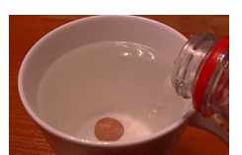
Procedure
- Put a coin into a cup
- View the coin through the side of the cup. Move your head backward until the coin is out of sight.
- Pour water into the cup until the coin re-appear.

In the figure 1(b), draw path of light to explain why we can see the coin by pouring water into the cup.

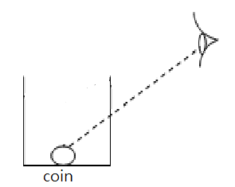  Figure 1(a) | 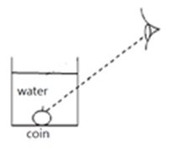  Figure 1(b)
Explain why we can see the coin by pouring water into the cup in few sentences.

When we pour water into the cup, the rays of the coin changes its direction due to refraction. Thus the light can enter into our eyes.

Task 2: Locate the position of image by method of “no parallax”

Watch a video clip about “no parallax”
https://www.youtube.com/watch?v=PIkksGUphV0

Procedure
- Each group is given a plane mirror, convex mirror, a ruler and two pins
- One pin is placed at 10 cm in front of plane mirror. Try to locate the image of the first pin with the other pin.
- Measure the distance between the second pin and the mirror.
- Repeat three times to locate the image of the first pin.
- Repeat step 2 to 4 using the convex mirror.

Results
Plane mirror | 1st trial | 2nd trial | 3rd trial | Average
Convex mirror | 1st trial | 2nd trial | 3rd trial | Average

Conclusions

- Where are the images formed by plane mirror and convex mirror? What is the nature of the images?

Both the images are behind the mirrors. It is a virtual image.

- Where are the image distances formed by plane mirror and convex mirror respectively?
The image distance is the same as the object distance in plane mirror.
The image distance is shorter than the object distance in convex mirror.

